Financial Risk ANalytics
Business Report

Guided Project
By
Rajesh Mambulli

Table of Contents
Guided Project 1
1. Context 4
2. Objective 4
3. Data Dictionary 4
4. Data Overview through Python 5
5. Checking the Statistical Summary of data 5
6. Checking for missing values in the data 6
7. Stock Price Analysis 6
8. Returns and Volatility Analysis 9
8.1 Average Return 9
8.2 Volatility 10
9. Visualizing Returns and Volatility 10
10. Conclusions and Recommendations 12

Table of Figures
Figure 1: Data Head 5
Figure 2: Shape of Data 5
Figure 3: Statistical Summary of data 5
Figure 4: Missing values in Data 6
Figure 5: Dish TV Price over Time 6
Figure 6: Infosys Price Over time 7
Figure 7: HUL Price Over TIme 7
Figure 8: Vodafone Idea Over Time 8
Figure 9: Cipla Price Over Time 8
Figure 10: Average Returns 9
Figure 11: Standard Deviation of Price 10
Figure 12: Returns and Volatility 10
Figure 13: Net return vs Volatility for stocks 11

Context
Investors face market risk, arising from asset price fluctuations due to economic events, geopolitical developments, and investor sentiment changes. Understanding and analysing this risk is crucial for informed decision-making and optimizing investment strategies.

Objective
The objective of this analysis is to conduct Market Risk Analysis on a portfolio of Indian stocks using Python. It uses historical stock price data to understand market volatility and riskiness. Using statistical measures like mean and standard deviation, investors gain a deeper understanding of individual stocks' performance and portfolio variability.
Through this analysis, investors can aim to achieve the following objectives:
- Risk Assessment: Analyse the historical volatility of individual stocks and the overall portfolio.
- Portfolio Optimization: Use Market Risk Analysis insights to enhance risk-adjusted returns.
- Performance Evaluation: Assess portfolio management strategies' effectiveness in mitigating market risk.
- Portfolio Performance Monitoring: Monitor portfolio performance over time and adjust as market conditions and risk preferences change.

Data Dictionary
The dataset contains weekly stock price data for 5 Indian stocks over an 8-year period. The dataset enables us to analyse the historical performance of individual stocks and the overall market dynamics.

Data Overview through Python
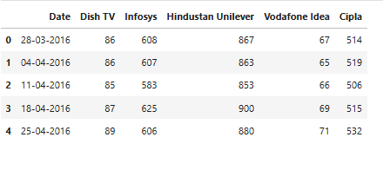
Figure 1: Data Head
This dataset has 418 rows and 6 columns

Figure 2: Shape of Data

Checking the Statistical Summary of data
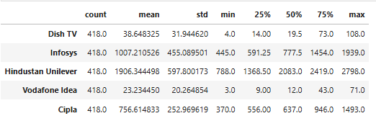
Figure 3: Statistical Summary of data
Observations
- Dish TV has a mean price significantly higher than its median, indicating a right-skewed distribution with a few high values pulling the average up. The high standard deviation suggests considerable price volatility and inconsistent performance over time.
- Infosys shows a strong upward trend with a high mean and median, though the mean being higher than the median also points to a right-skewed distribution. Its moderate-to-high standard deviation reflects healthy growth accompanied by some volatility.
- Hindustan Unilever has a median price higher than the mean, suggesting a left-skewed distribution. This may indicate that the stock has experienced a decline in recent periods after reaching higher levels earlier in the timeline.
- Vodafone Idea exhibits a low median and a relatively high standard deviation, with a mean much higher than the median. This reflects a right-skewed distribution and suggests that while the stock has mostly traded at low levels, there have been occasional sharp spikes—likely due to speculative activity or news-driven rallies.
- Cipla demonstrates a healthy growth profile with a mean and median that are relatively close, though still right-skewed. Its moderate standard deviation indicates steady performance with manageable fluctuations.

Checking for missing values in the data
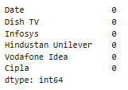
Figure 4: Missing values in Data

Stock Price Analysis
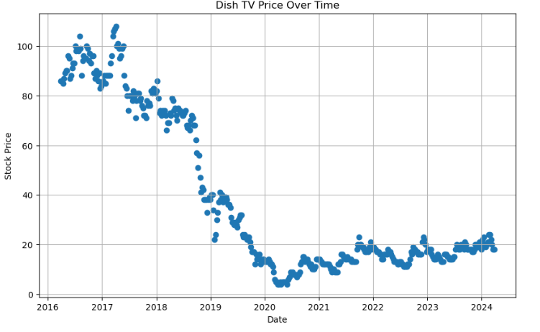
Figure 5: Dish TV Price over Time
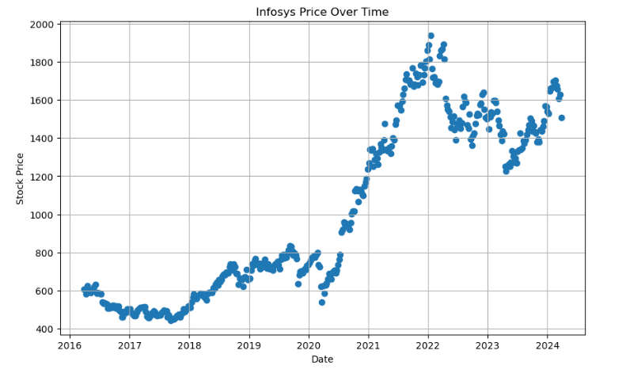
Figure 6: Infosys Price Over time
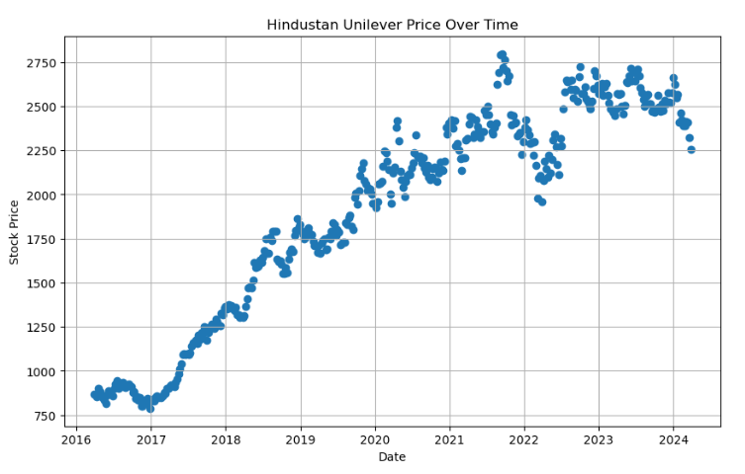
Figure 7: HUL Price Over TIme
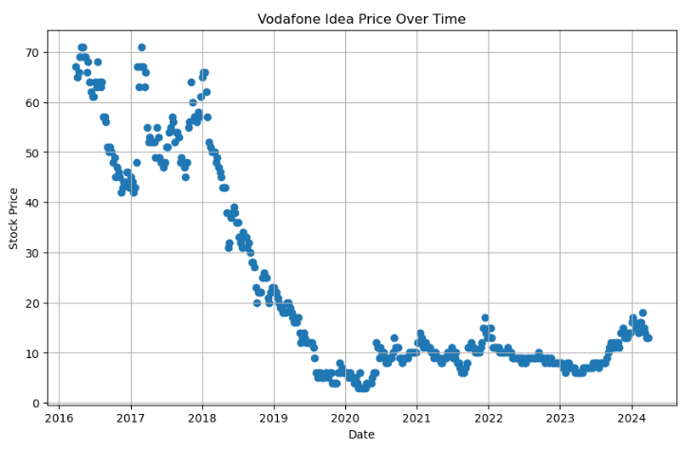
Figure 8: Vodafone Idea Over Time
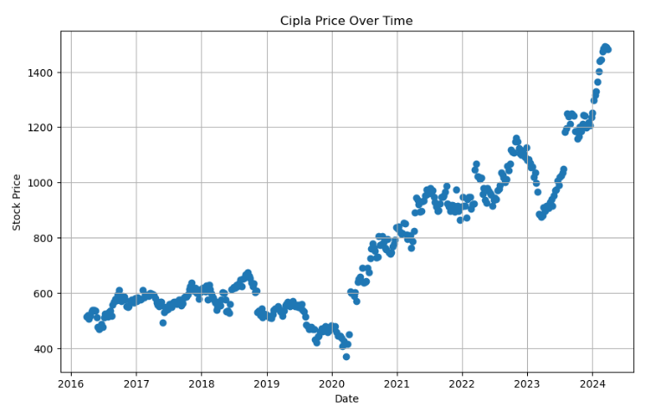
Figure 9: Cipla Price Over Time

Inference
- Dish TV has experienced a significant and prolonged decline in stock price, indicating sustained underperformance and high market risk, with little sign of recovery in recent years.
- Infosys has shown a strong and consistent upward trend, especially during the pandemic years, reflecting robust fundamentals and investor confidence in the technology sector.
- Hindustan Unilever demonstrated impressive growth until 2020, after which it entered a phase of volatility and mild decline, suggesting possible market saturation or macroeconomic pressures affecting consumer demand.
- Vodafone Idea has undergone a dramatic collapse in value, with occasional speculative spikes, highlighting its status as a highly volatile and distressed stock with elevated risk.
- Cipla has shown steady and accelerating growth, particularly after 2020, positioning it as a relatively low-risk, high-consistency performer in the pharmaceutical sector.

Returns and Volatility Analysis

Average Return
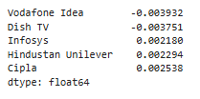
Figure 10: Average Returns
Inference
- Cipla has the highest average return at 0.2538% per week, indicating strong and consistent performance over time.
- Hindustan Unilever and Infosys follow closely, with average weekly returns of 0.2294% and 0.2180% respectively—both reflecting solid long-term growth potential.
- Dish TV and Vodafone Idea have negative average returns (−0.3751% and −0.3932% per week), confirming their poor historical performance and reinforcing their classification as high-risk, underperforming assets.

Volatility

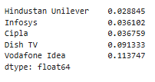
Figure 11: Standard Deviation of Price
Inference
- Cipla offers the best risk-return trade-off high return with moderate volatility.
- Hindustan Unilever is the most stable stock, with the lowest volatility and a solid return—ideal for conservative investors.
- Infosys balances growth and risk well, making it a strong core holding.
- Dish TV and Vodafone Idea have both high volatility and negative returns, making them unattractive from a risk-adjusted perspective.

Visualizing Returns and Volatility
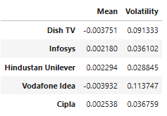
Figure 12: Returns and Volatility
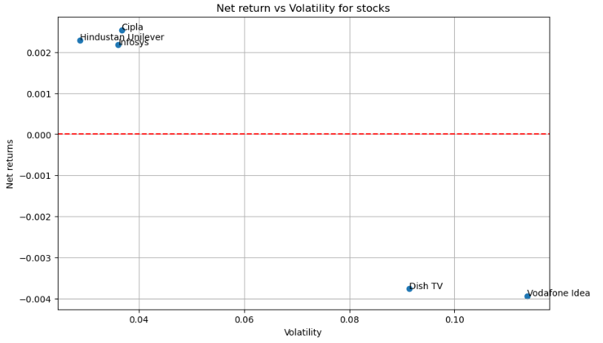
Figure 13: Net return vs Volatility for stocks
Inference
- Cipla, Hindustan Unilever, and Infosys form a favourable cluster with:
  - Low volatility (around 0.04)
  - Positive net returns (around 0.002 or 0.2% weekly)
  - These stocks offer a strong risk-return profile and are ideal for building a stable, growth-oriented portfolio.
- Dish TV and Vodafone Idea are positioned in the high-risk, low-return quadrant:
  - High volatility (above 0.08)
  - Negative net returns (around −0.004 or −0.4% weekly)
  - These stocks are underperforming and carry significant downside risk, making them unsuitable for conservative or risk-averse investors.

Conclusions and Recommendations
Insights
- Cipla emerges as the most attractive stock, offering the highest average weekly return (0.2538%) with moderate volatility (0.0368). It demonstrates consistent performance and strong risk-adjusted returns
- Hindustan Unilever (HUL) shows the lowest volatility (0.0288) and a solid return (0.2294%), making it a reliable defensive stock—ideal for stability-focused investors.
- Infosys balances growth and risk well, with a strong return (0.2180%) and moderate volatility (0.0361). It is a robust core holding for long-term portfolios.
- Dish TV and Vodafone Idea both exhibit negative average returns (−0.3751% and −0.3932%) and high volatility (0.0913 and 0.1137, respectively). These stocks are underperforming and highly risky, suggesting structural or financial distress.
- The return vs. volatility plot clearly separates high-quality stocks (Cipla, HUL, Infosys) from speculative or declining ones (Dish TV, Vodafone Idea), offering a visual guide for portfolio construction.
Recommendations
- Prioritize allocation to Cipla, HUL, and Infosys:
- These stocks offer the best trade-off between return and risk.
- Consider overweighting Cipla for growth and HUL for stability.
- Avoid or underweight Dish TV and Vodafone Idea:
- Their negative returns and high volatility make them unsuitable for risk-averse or long-term investors.
- Only consider them if you have a high-risk tolerance and a speculative strategy.
- Monitor performance regularly:
- Reassess return and volatility metrics periodically to adjust your portfolio as market conditions evolve.

